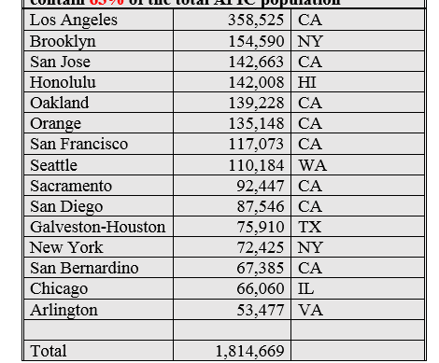

**Arch/diocese**  **Catholic** **Population** **State**

**Fifteen (arch)dioceses with the most Asian and Pacific Island Catholics contain 63% of the total APIC population** 1

1Tricia C. Bruce, “National Study of Asian & Pacific Island Catholics: A Demographic Primer”(a report presented during the meeting for the Subcommittee on Asian and Pacific Island Affairs (SCAPA), St. Louis, MO. June, 9, 2015).